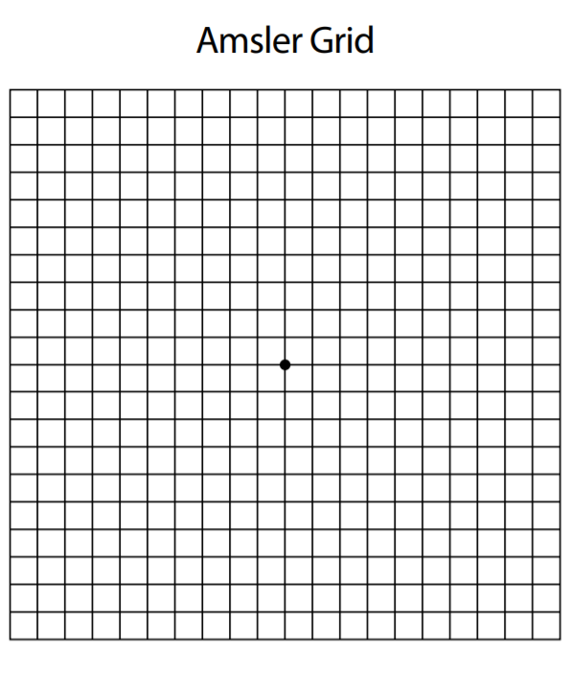

Directions for using the Amsler Grid:

- Test with your glasses used for reading.
- Hold the grid approximately 14-16 inches from your eyes.
- Test each eye separately. Cover your other eye with your hand.
- Keep your eye focused on the dot in the center of the grid and answer these questions:
  - Do any of the lines in the grid appear wavy, blurred or distorted?
  - Do all of the boxes in the grid look square and of the same size?
  - Are there any holes, missing boxes or dark areas in the grid?
  - Can you see all corners and sides of the grid while keeping your eye on the dot in the center?
- Repeat while covering your other eye.

IMPORTANT – Report any changes you see on the grid to your eye doctor immediately.

